**Data Structure Assignment No.2**

**Questions 1:**

Create an empty list. Accept 10 numbers from the user and append to it the list if it is an even number.

**Code:-**

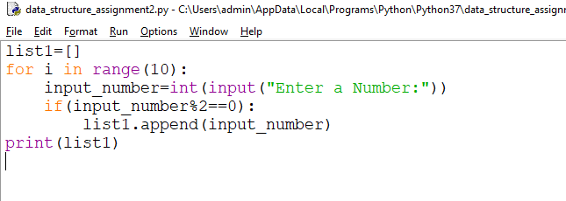

**OUTPUT:-**

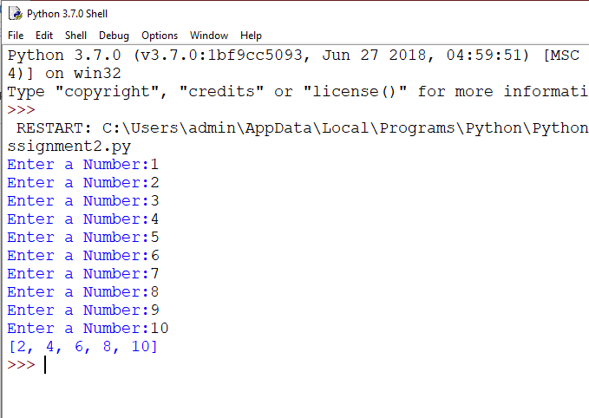

**Questions 2:**

Create a notebook on LIST COMPREHENSION. This exercise is to put you in a Self-learning mode

**Code:**

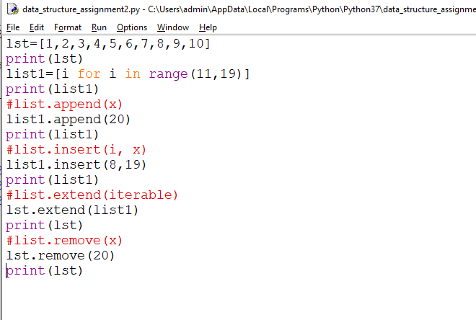

**OUTPUT:-**

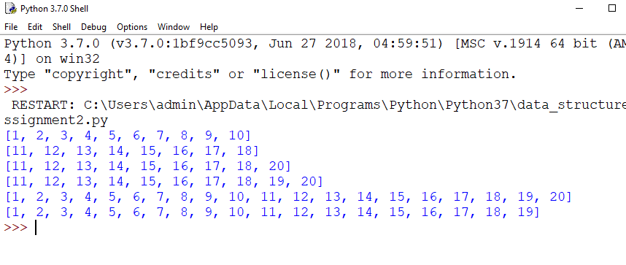

**Questions 3:**

You have seen in the videos how powerful dictionary data structure is.

In this assignment, given a number n, you have to write a program that generates a dictionary d which

contains (i, i*i), where i is from 1 to n (both included).

Then you have to just print this dictionary d.

**Code:-**

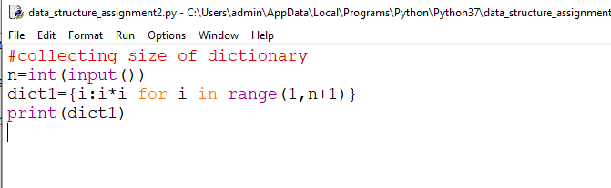

**OUTPUT:-**

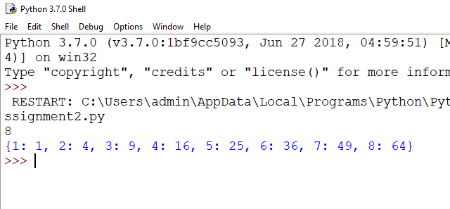

**Questions 4:**

There is a robot which wants to go the charging point to charge itself.

The robot moves in a 2-D plane from the original point (0,0). The robot can

move toward UP, DOWN, LEFT and RIGHT with given steps.

**Code:-**

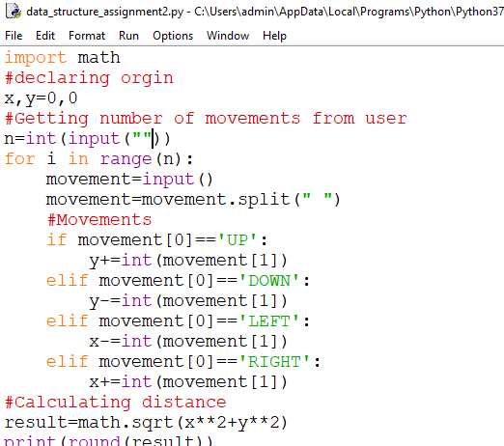

**OUTPUT:-**

